**Output:**

**ss1(Creating Microservices for account and loan)**

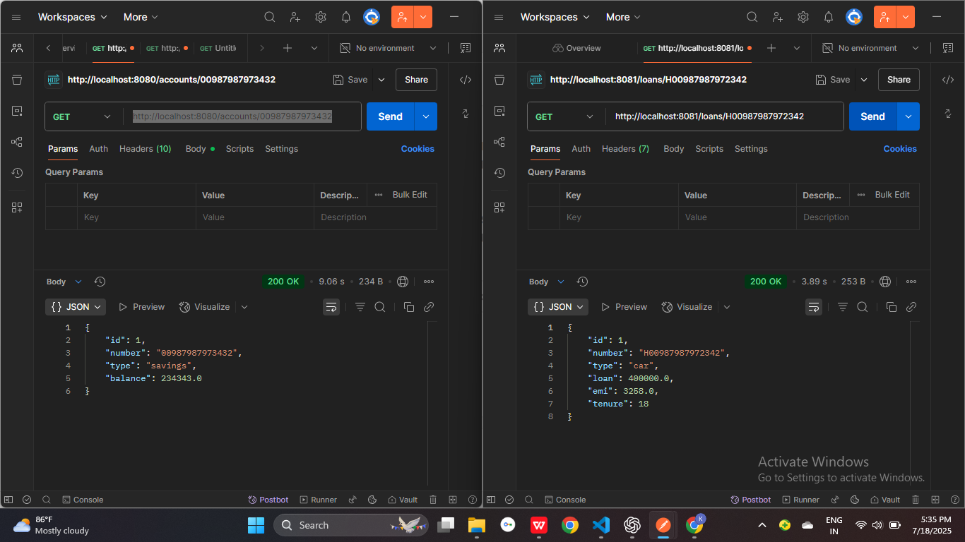

**Ss2(Create Eureka Discovery Server and register**

**microservices)**

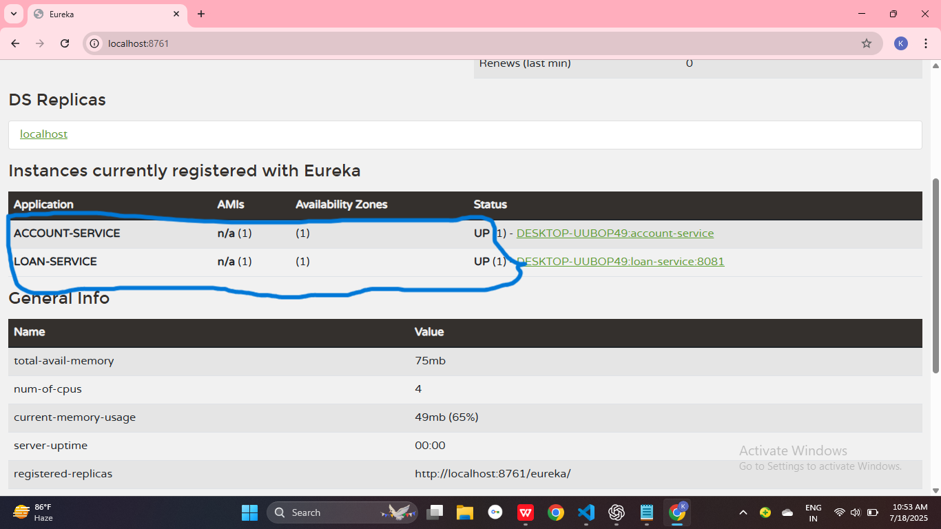

**Ss3(Create Simple Microservice greet-service)**

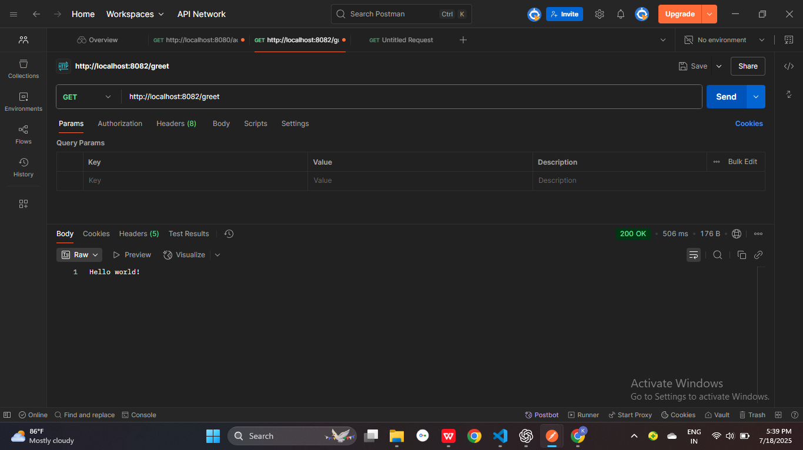

**ss4(Api Gateway output at** <http://localhost:9090/greet-service/greet>**)**

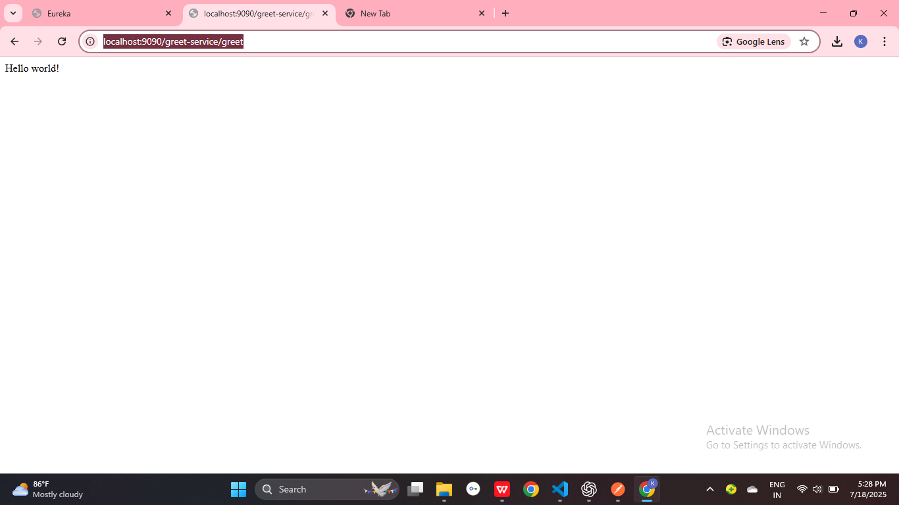

**ss5(All client services)**

